Types of Settlement Networks
# Source: AI Source: Provided by: [Data Path: Persons Table -> ID Column: 1, Name_En Column: Motasem Essam] -> From: [ChatGPT] on [1/21/2026]
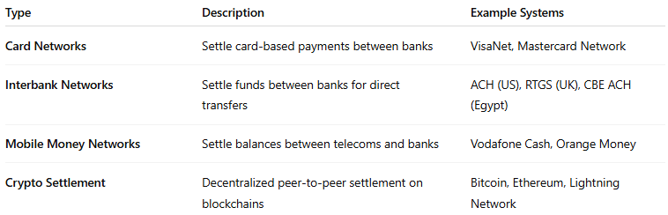

Type | Description | Example Systems
Card Networks | Settle card-based payments between banks | VisaNet, Mastercard Network
Interbank Networks | Settle funds between banks for direct transfers | ACH (US), RTGS (UK), CBE ACH (Egypt)
Mobile Money Networks | Settle balances between telecoms and banks | Vodafone Cash, Orange Money
Crypto Settlement | Decentralized peer-to-peer settlement on blockchains | Bitcoin, Ethereum, Lightning Network

